**Mid Term Exam Sample**

**CS 521**

**Stevens Institute of Technology**

Closed books/notes

***20 points***

**1 a)**  Define traffic Intensity in a computer network.

In a computer network, an entry router with a 200 Mbits link receives 200 packets per second and each packet size is 400 bytes. Is the system is stable?

**b)** Suppose N packets arrive simultaneously every (L/R)N seconds (where L is packet size, R is the transmission rate. Then first packet transmitted has no queueing delay; what is the queueing delay for the second packet?

**c)** Car-caravan analogy.  **Given:**

1. The cars propagate at 100km/hr.
2. A tollbooth services a car at a rate of one car every 12 seconds.
3. Also we know from the problem description below that tollbooths are 75km apart
4. Suppose the caravan of 10 cars travels 150 km, beginning in front of one tollbooth, passing through a second tollbooth, and finishing just after a third tollbooth. What is the end to end delay?

**d)**  In the following Fig, if Rs = 2 Mbps, Rc = 1 Mbps, R= 5 Mbps, and the common link divides its transmission rate equally among the 10 downloads.

What is the end-to-end throughput for each download?

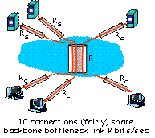

1. ***Points***
2. **a)** What are the similarities and differences between HTTP and FTP?

What are the reasons web caching has seen deployment in the Internet ?

***8 Points***

1. Consider the following figure, for which there is an institutional network connected to the Internet. Suppose that the average object size is 850,000 bits and that the average request rate from the institution’s browsers to the origin servers is 15 request per second. Also suppose that LAN bandwidth capacity is 100 Mbps and Access bandwidth capacity is 15 Mbps. **What are Utilizations: $U_{Access Link}$ and $U_{LAN}$?**

***10 Points***

**c)**  Write a TCP client-server application program (Client_TCP and Server_TCP) where

* client reads two numbers from standard input (**inFromUser** stream) , sends to server via socket (**outToServer** stream)
* server reads these two numbers from socket

***4 points***

**3 a)** What are the differences between stop-and –wait and pipelinng protocol?

How pipelining protocols help utilization in TCP/IP communication?

***8 Points***

**b)** For Stop-and-wait operation calculate

1. Utilization (fraction of time user is busy sending) for the following figure with: 1 Gbps link, 15 ms e-e prop. delay, 1KB packet .

3. Explain your finding in terms of network performance

***8 Points***

**c)** Now consider the pipelining technique with window size = 5 packets and calculate

1. Utilization (fraction of time user is busy sending) for the following figure with: 1 Gbps link, 15 ms e-e prop. delay, 1KB packet .

3. Explain your finding in terms of network performance

1. ***Points***
2. **a)** Host A and B are directly connected with a 100 Mbps link. There is one TCP connection between the two hosts, and Host A is sending to Host B an enormous file over this connection. Host A can send its application data into its TCP socket at a rate as high as 120 Mbps but Host B can read out of its TCP receive buffer at a maximum rate of 60 Mbps. Describe the effect of TCP flow control.
3. Explain 3 way hand shake in TCP connection setup using HTTP protocol with message transactions diagram.
4. Explain how congestion control works in TCP. Define slow start, Congestion Avoidance and Fast recovery explaining the following diagram:

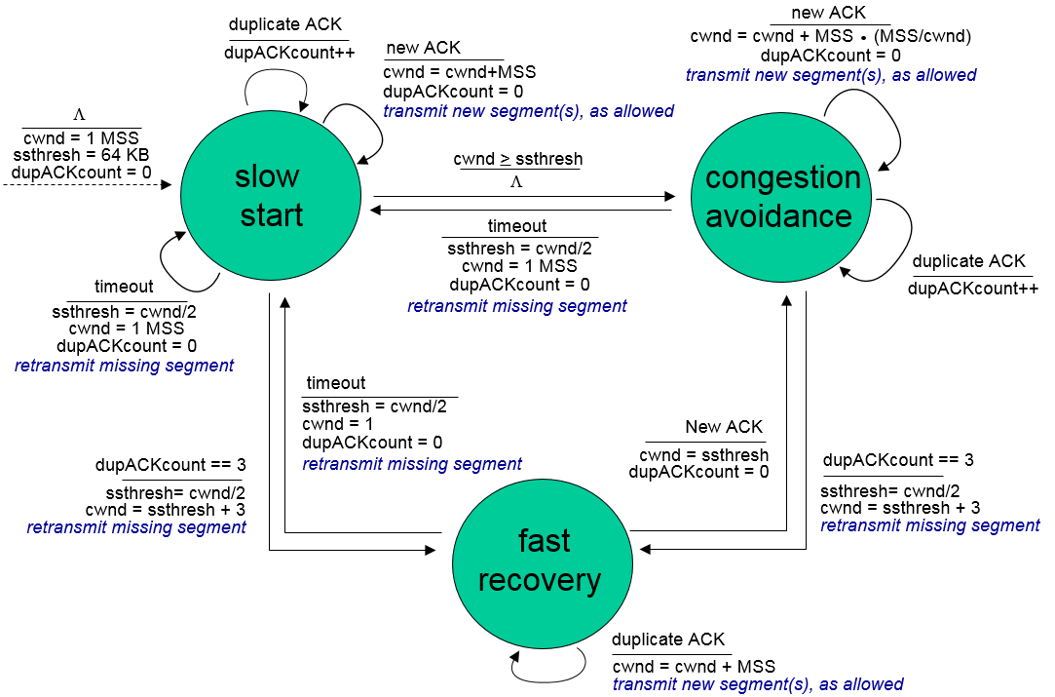

1. Can you configure your browser to open multiple simultaneous connections to a Web site? What are the advantages and disadvantages of having a large number of simultaneous TCP connections?

20 Points

1. Consider a TCP connection between Host A and Host B. Suppose that the TCP segments travelling from Hos A to Host B have source port number x and destination port number y. What are the source and destination port numbers for the segments travelling from Host B to A?
2. Suppose two TCP connections are present over some bottleneck link of rate R bps. Both connection have huge file to send (in same direction over the bottleneck link). The Transmission of the file start at the same time. What transmission rate would TCP like to give to each of the connections?
3. Suppose process in Host has UDP socket with port number 6789. Suppose both Host A and Host B each send a UDP to Host C with destination port number 6789. Will both these segments be directed to the same socket at Host C? If so, how will the process at Host C know that these two segments originated from two different Hosts?
4. Suppose Host A sends two TCP segments back to back to Host B over a TCP connection. The first segment has sequence number 90; the second has sequence number 110.
   1. How much data in the first segment?
   2. Suppose the first segment lost but the second segment arrives a B. In the acknowledgement that Host B sends to Host A, what will be the acknowledgement number?